**CMP 4271: Session 3 Online Diary - Territorial Acquisition Game**

The objective of the game is to claim the most territory.

The materials needed to play the game are a rectangular board made up of 77 hexagonal tiles (shown in Figure 1), a die, 14 Territory Cards and 154 double-sided counters, with 77 counters red on one side, blue on the other, and the other 77 yellow on one side and green on the other.

**Rules and Mechanics**

At the beginning of the game, each player picks up 2 Territory cards, and rolls the die. In the order of rolling scores highest to lowest, each player starts in hexagons 1, 2, 3 or 4 (see Figure 1). In each round, the players take their turns in this same order. In a round, each player rolls the die and can claim this number of hexagons. Each player’s territory starts at three hexagons and is increased by claiming an adjacent hexagon. When a hexagon is claimed, the player places a counter on the hexagon with their colour facing upwards. Once all players have had a turn, a round has been completed and player one plays again.

When a player claims a ‘?’ hexagon (see Figure 1), they pick up a Territory card from the pile. Territory cards have 4 attributes: Military Strength, Intelligence, Troops, and Espionage. Cards value each attribute from 0-10. Territory cards are used when a player wants to claim a hexagon in another player’s territory, this is known as a ‘Battle’. In a Battle, the player who is challenged names an attribute. Both players choose one of their cards to use. Whichever player’s card has the higher attribute value, claims the hexagon. If the values are equal, another two cards are played. Losing a Battle ends a player’s turn. If a player has no remaining Territory cards, they cannot start a Battle, and lose any Battle for their own territory. At the end of a battle, all cards used by both players are discarded. Once all Territory cards have been used, the cards are shuffled and re-dealt, so each player has 2 cards, plus any additions for ‘?’ hexagons in their territory.

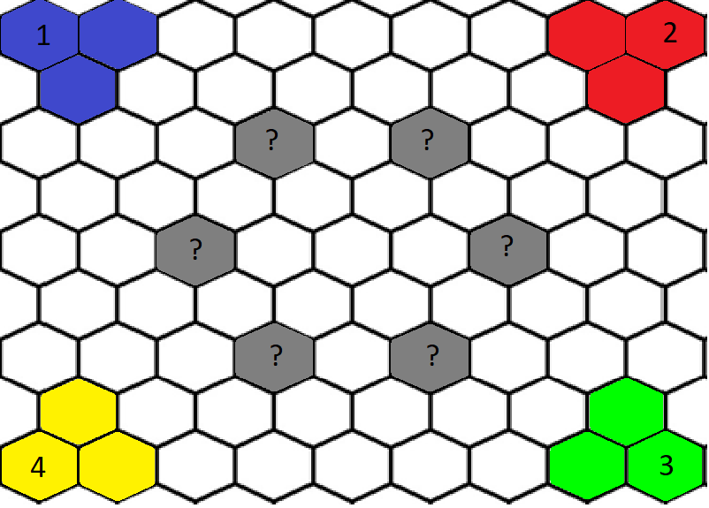The winner is the player with the most territory after 15 rounds or the player who has claimed the entire board.

Figure 1. Final board design. ‘A’ shows Player 1’s starting area in blue. ‘B’ shows Territory card hexagons.

B

A

**Play Testing**

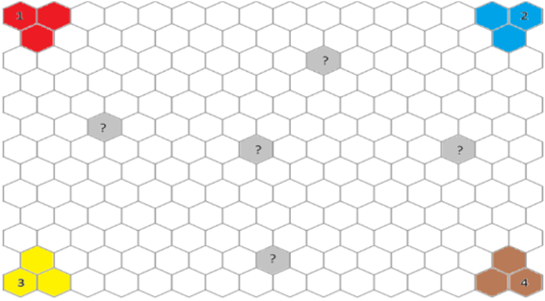As internal play testing begun, it was clear the original board was too large, with 202 hexagons, and there would be too many counters (see Figure 2). It was decided that a smaller, more simple board, with only 77 hexagons, would be beneficial, plus changing numbers so play continues clockwise (see Figure 1). No external play testing was carried out.

Figure 2. Original board design

**Working as a Team**

Creating this game as a team was useful as different members were able to do different tasks, such as designing the board and developing mechanics, at the same time. As our group was only 3 members, it also meant each member had a greater impact on the development of the game.

By working as a team, individual ideas were developed and adapted for the better to improve the game, and communication improved as the session went along.

However, time management was an issue, resulting in no external play testing being done. Furthermore, only one team member had access to the presentation, with others just providing input, instead of directly adding information themselves.

**Team Members**

Josh Wye

Ricardo Nguyen

Rowan Noble